**Project 4:**

**Control Led using Push Button**

**Description**: In this project , we will learn how a led is controlled by a push button.

**Required Hardware:**

* Arduino Uno.
* Breadboard.
* Jumper wire.
* 6 LED
* Resistor.
* USB type A/B.
* Push button

**LED**:

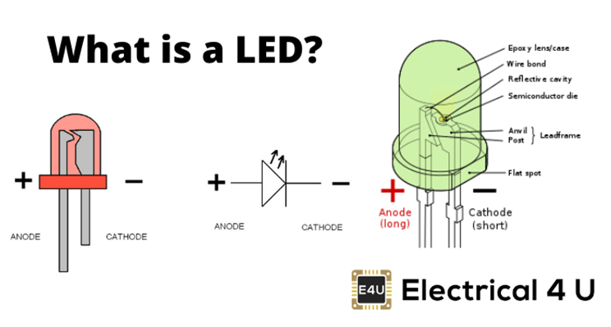

**Push Button:**

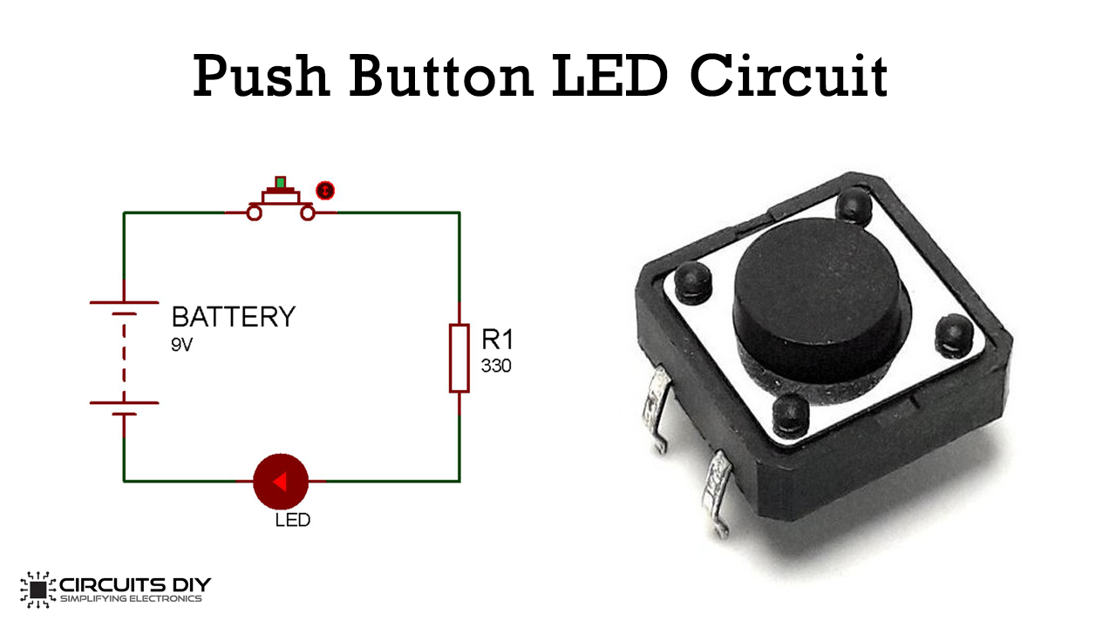

**Specifications:**

* Mode of operation: Tactile feedback
* Power Rating: MAX 50mA 24V DC
* Insulation Resistance: 100 Mohm at 100v
* Operating Force: 2.55± 0.69 N
* Operating Temperature: -20 to +70 ℃

**Circuit Diagram:**

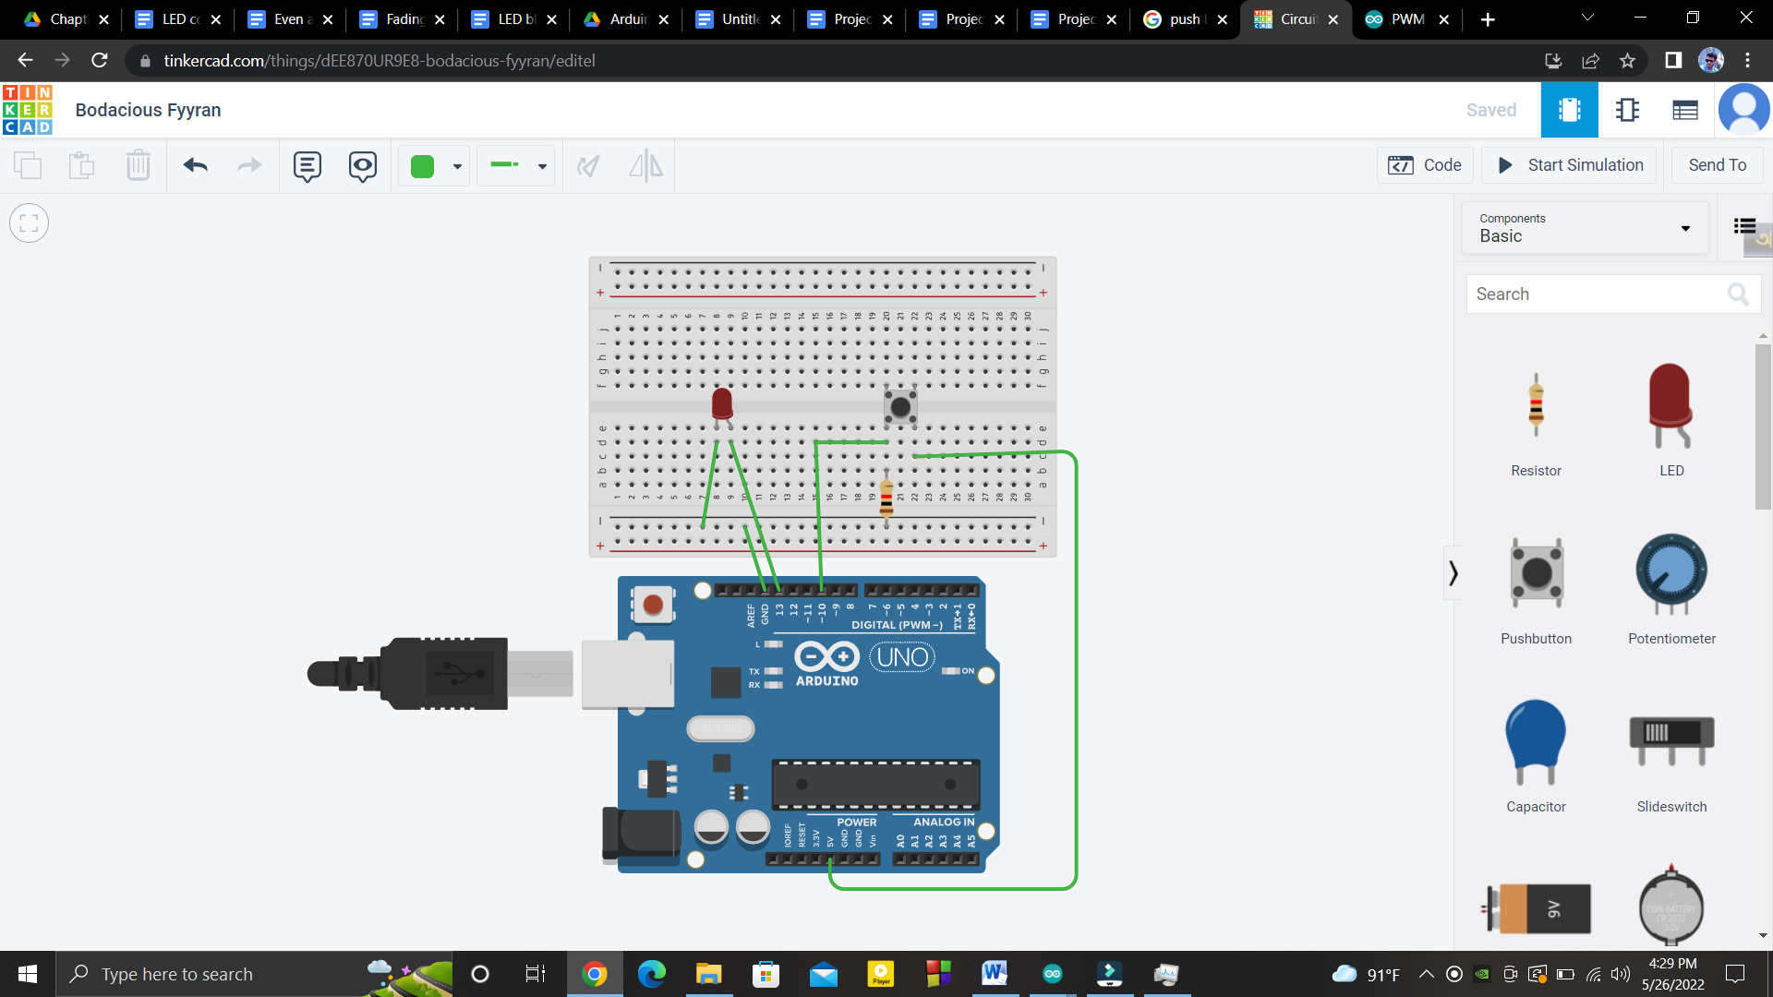

**Pin Configuration:**

* Arduino’s +5V connect to button’s one hand
* And button’s another hand connect to arduino’s pin 10 and buttons this hand also connected to a resistor to GND.
* Led’s anode connected to arduino’s pin 13.
* And led’s cathod connected to the GND.

**Code:**

| int pin1=13;  int pin2=10;  int pin3;  void setup()  {  pinMode(pin1, OUTPUT);  pinMode(pin2,INPUT);  }  void loop()  {  pin3= digitalRead(pin2);  if(pin3==1)  {  digitalWrite(pin1,HIGH);  }  else  {  digitalWrite(pin1,LOW);  }  } |
| --- |